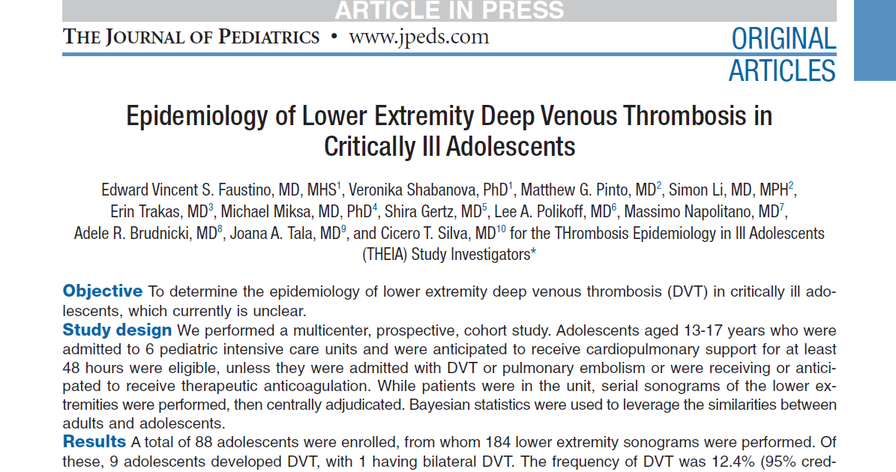

Goal: Estimate the frequency (prevalence) of DVT among this population AND compute the probability this frequency (prevalence) is greater than 10%.
Priors: From adult studies the authors determine a DVT frequency of 15% with 95% Confidence interval 6.5% and 26.5%
Suitable prior distribution: Beta(7,39)
Data: 88 critically ill children, 9 developed DVT
Use JAGS to combine this information and get a Posterior estimate of the prevalence of DVT.
In adults, if the probability of a DVT is > 10%, then they will treat with prophylactic medication.

